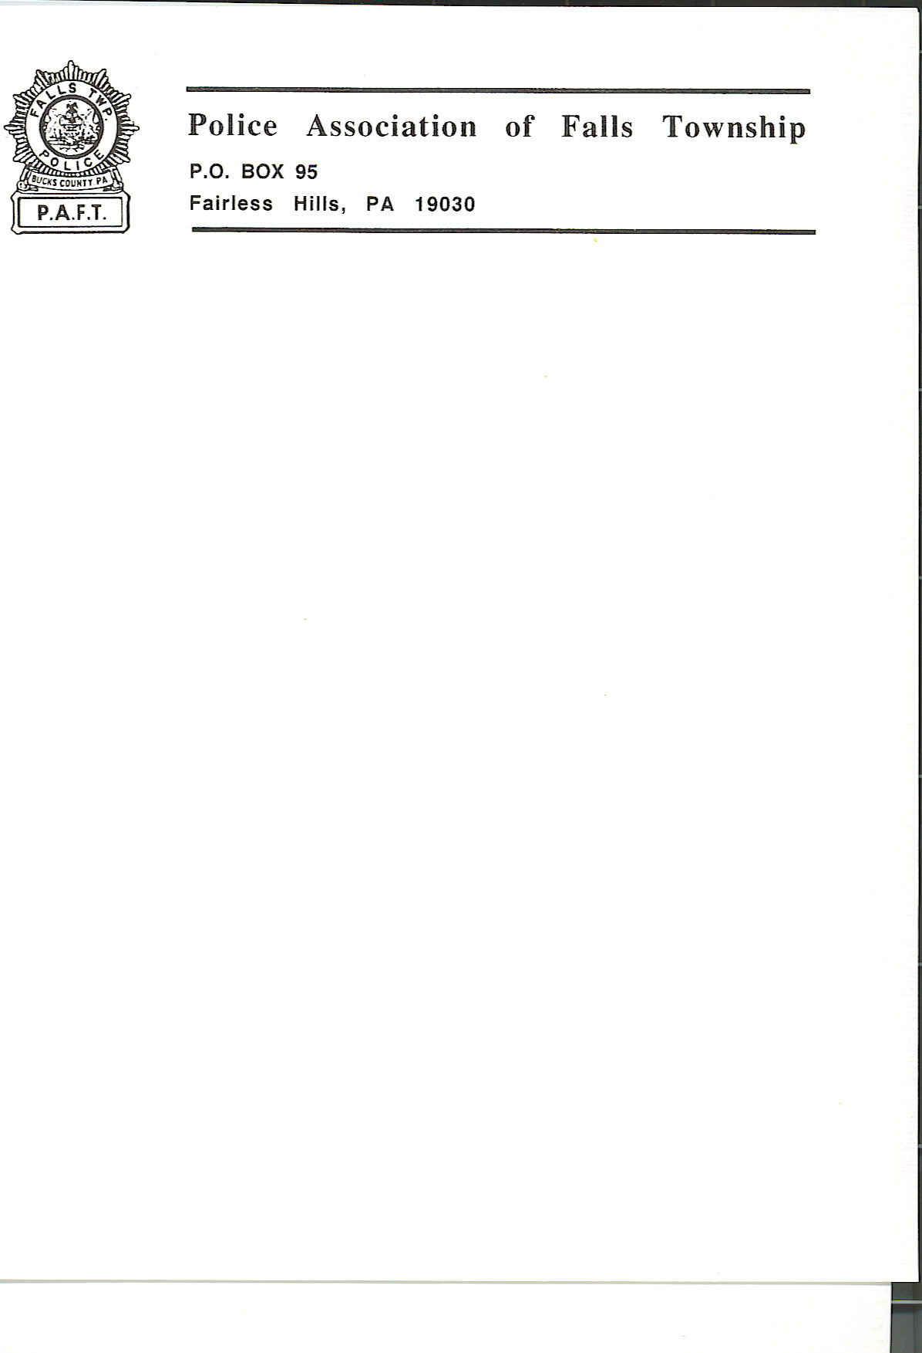

September 25, 2023

My name is George Thomas, I am a Falls Township Police Officer and the president of our union, PAFT, the Police Association of Falls Township.

I am here tonight, on behalf of PAFT, to make a statement regarding the great concerns caused by the Township and their ongoing behavior relating to the police department.

Under the pretense of oversight, abusive overreach exists and expands. These expansive and evolving efforts include interference with a Lieutenant promotional process, depriving a police officer of his due process rights and terminating him while braggadociously boasting they didn’t care, let him fight it, all done in secrecy, resulting in his reinstatement and the filing of a lawsuit against the Township. Staying with discipline, the Board, without any discourse with Chief Whitney or police administration, has made recommendations for discipline, for serious violations including lying, go completely away without explanation. By virtue of doing so, one such recommended case instead went from termination to promotion to Lieutenant. The overreach goes on, personnel assignments, historically left to the Chief of Police are now being made by the Board, without any dialogue. This includes telling us who should and shouldn’t be Field Training Officers, not allowing us to provide a Task Force Officer to the County, changing our uniforms while telling Chief Whitney he isn’t allowed to wear a uniform, forbidding the Chief of Police to fulfill his legal obligations to inform the District Attorney’s Office regarding possible Brady material without Board approval, not allowing the Chief of Police to initiate an internal investigation based on misconduct or policy violations with Board approval, hiring a qualified individual to replacement a retiring employee for an advertised position, only to demand he be fired and the position readvertised, leading to a complete revamp of how all new employees must be hired, then in unequivocal conflict with this new written Township policy, hiring Agenda Item 2, not allowing us to manage or otherwise post on police department social media accounts unless it involves an emergency, Board members demanding investigations into personnel, and much more… All of this predictably leads to Agenda Item 10 tonight, inserting themselves into our hiring process, which will consist of a political hire, Agenda Item 2, married to a handpicked Lieutenant and handpicked “community members,” to deliver a fixed outcome.

It is apparent that the issues the Board has created are systemic, and based on three core interrelated behaviors.

In no particular order, the first is transparency. As Supreme Court Justice Louis Brandeis said over a century ago: “Sunlight is said to be the best of disinfectants.” This statement is as true now as it was then. The Township’s repeated violations of Sunshine Act are not out of convenience or ease of schedule. They are instead calculated, and intentionally clandestine measures designed to conceal major personnel matters, not for fear of public disapproval, but public resistance.

The second is the unprofessional and irresponsible refusal to allow the head of this agency, Chief Whitney, to attend and interact with board members during executive sessions when matters, even critically important matters, of the police department are being discussed. This spiteful pettiness began in November 2021, and continues today.

In an obvious furtherance of excluding Chief Whitney, “coincidentally” he was informed this morning that his longstanding mandatory attendance at monthly Board Meetings will no longer continue unless specifically directed to attend. Therefore, there will no longer be any regular monthly report to the Board/community going forward or a chance for a taxpaying resident to ask the Chief of Police any concerns they might have. Despite the presence of Agenda Item 10 and his relevance to speak on the subject, he was directed to not attend tonight’s meeting, explaining his absence.

Juxtapose the aforementioned controlling interest to manage the minutiae of the day-to-day operations of the police department while excluding the head of the agency and the union.
The Board’s substitute for professional, regular and appropriate dialogue is to immaturely rely on inappropriate personal relationships with a few Falls Township Police Officers, who have benefited from these relationships and who have and continue to share confidential PAFT correspondence with the Board. This relationship also includes Board members sharing highly confidential and sensitive information with these officers via email.

In a similar fashion, the Township’s labor counsel, Obermeyer, Rebmann, Maxwell and Hippel, has similarly been disinvited to executive sessions, once their professional legal opinion was against the interest of board members.
Decision-making is a process and important stakeholders and subject matter experts with vast institutional knowledge are elementary aspects of that process. How can one, or in this case five, make a decision in a silo without any context, because, Mr. Dence, everything isn’t always “straightforward.”

The third is the complete and offensively inexcusable lack of civic engagement by this community. It is predictable that five people, left to their own devices, in almost always vacant meeting rooms, would be more than enough encouragement to do what’s personally and politically expedient, not necessarily what’s been comprehensively examined, is sound and well above reasonable scrutiny.

Lastly, as indicated in a recent article written by Broad and Liberty, the fact that an electrical union, based in Trenton, New Jersey, would give the chairman of the board of supervisors, in Falls Township, $214,000, and the vice chairman, $76,000 essentially making them kingmakers to bankroll candidates’ campaigns easily speaks to an incredible incentive to vote at their direction along party lines and not request sensible and baseline expectations such as including the chief of police and labor counsel at relevant executive sessions. An obvious and reasonable question is why would an out of state electrical union gift $300,000, to two supervisors in a community of 34,000 residents. Influence peddling is not an inference one could draw, instead, a conclusion.

We are making an open appeal by the effected to the effected, residents, taxpayers, constituents and business owners, please become civically engaged. This includes voting but also attending meetings of local government, asking questions and demanding answers.

The days of Mr. Clarke’s rote statement of “we had an executive session where matters of personnel and possible litigation,” which is in of itself a violation of the Sunshine Act by its insufficiency, must end.

Secondly, we appeal to the board. Please rise above personal pettiness, based on Chief Whitney’s cooperation with a federal investigation you brought to the Township’s doors, and invite he and labor counsel to executive session just like every responsible, functional governing municipality in Bucks County, Pennsylvania, and beyond. Allow Mr. Takita to function as a Township Manager, the job was hired for and paid to perform.
Finally, as consultation with PAFT’s legal counsel determined that any such proposed ordinance or change to the contemporary hiring process is subject to mandatory bargaining with PAFT, we ask that you table Agenda Item 10.

